Lab Assignment: Grafana Installation and

Dashboard Creation for Ubuntu Server Performance

Objective:

This lab guides you through the installation of Grafana on an Ubuntu machine, setting up the Azure Monitor agent for performance metrics collection, and creating a dashboard in Grafana to visualize the collected metrics.

Prerequisites:

* An Ubuntu server (version 18.04 or later)
* An Azure account with permissions to create and manage Azure resources
* Basic understanding of Linux command line interface Lab Tasks:

Task 1: Prepare Your Ubuntu Server

sudo apt-get update && sudo apt-get upgrade

# Task 2: Install Grafana

* Add Grafana's official APT repository and install Grafana:

|  |
| --- |
| sudo apt-get install -y apt-transport-https software-properties-common wget sudo mkdir -p /etc/apt/keyrings/  wget -q -O - https://apt.grafana.com/gpg.key | gpg --dearmor | sudo tee /etc/apt/keyrings/grafana.gpg > /dev/null echo "deb [signed-by=/etc/apt/keyrings/grafana.gpg] https://apt.grafana.com stable main" | sudo tee -a  /etc/apt/sources.list.d/grafana.list  sudo apt-get update sudo apt-get install grafana |

* Start and enable the Grafana server:

sudo systemctl daemon-reload sudo systemctl start grafana-server sudo systemctl enable Grafana grafana-server

* Verify the service is running

sudo systemctl status grafana-server

# Enable Port 3000

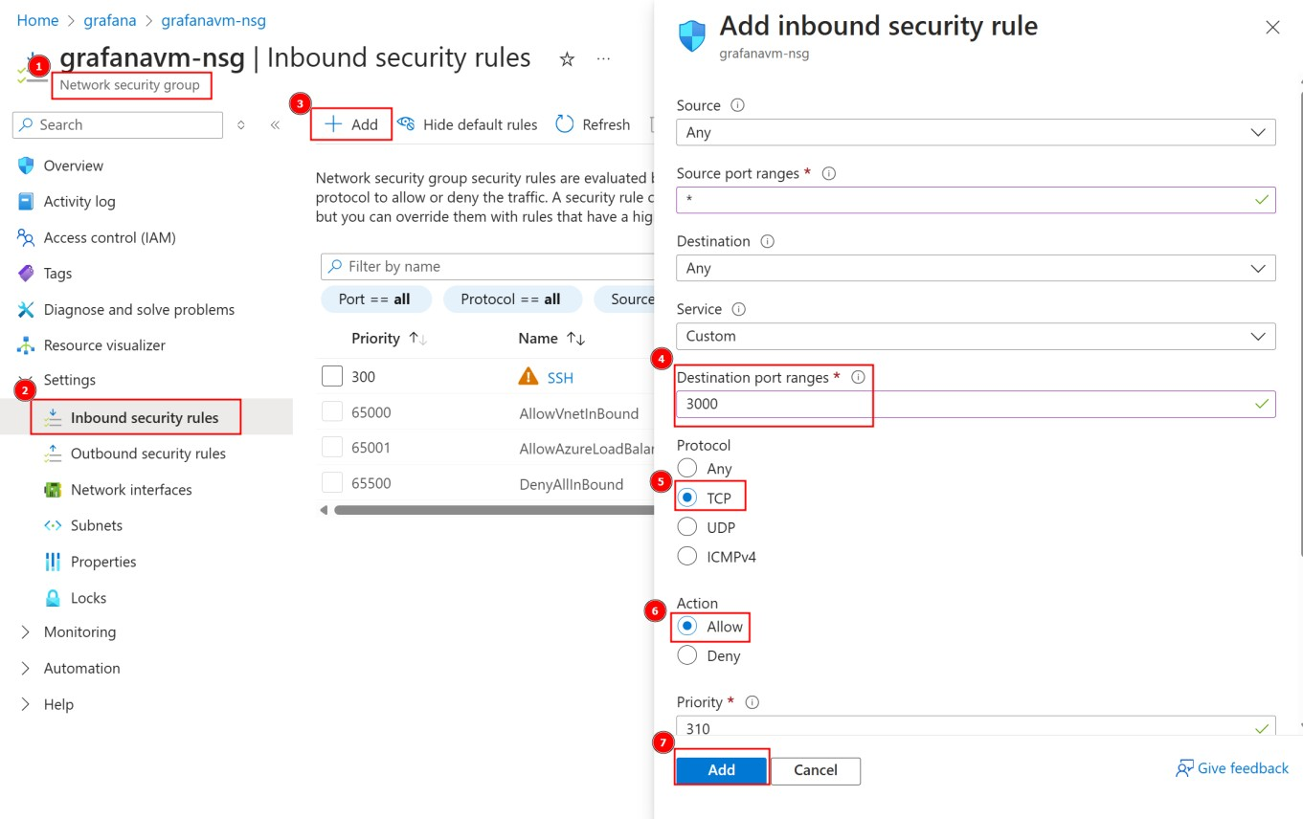

# Make sure you can reach your Grafana server

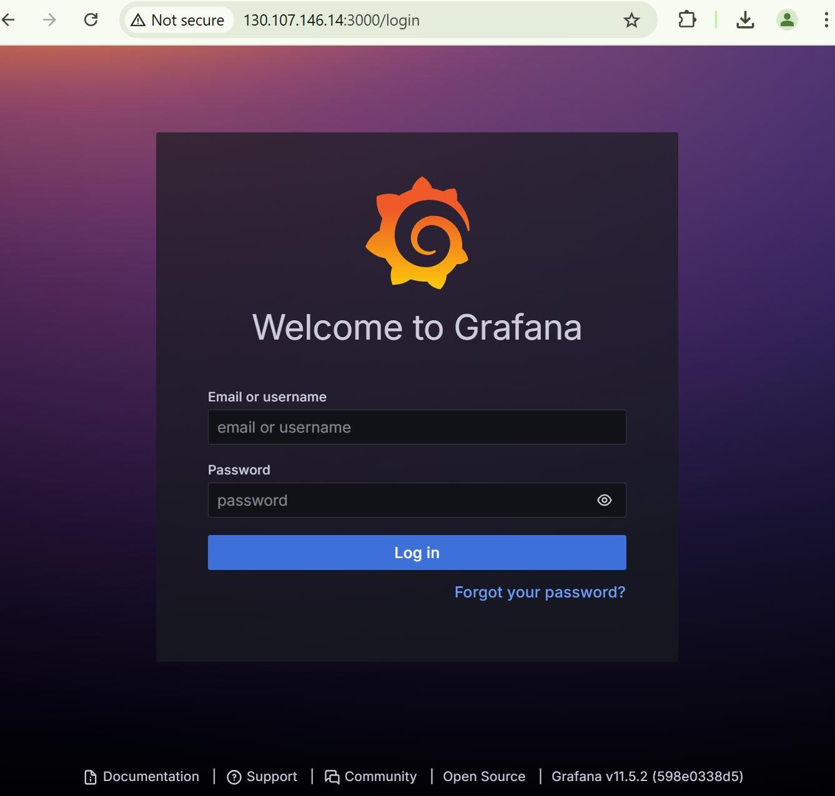

# Task 3: Connect Grafana to Azure Monitor

* Enable Managed Identity in your Grafana VM:

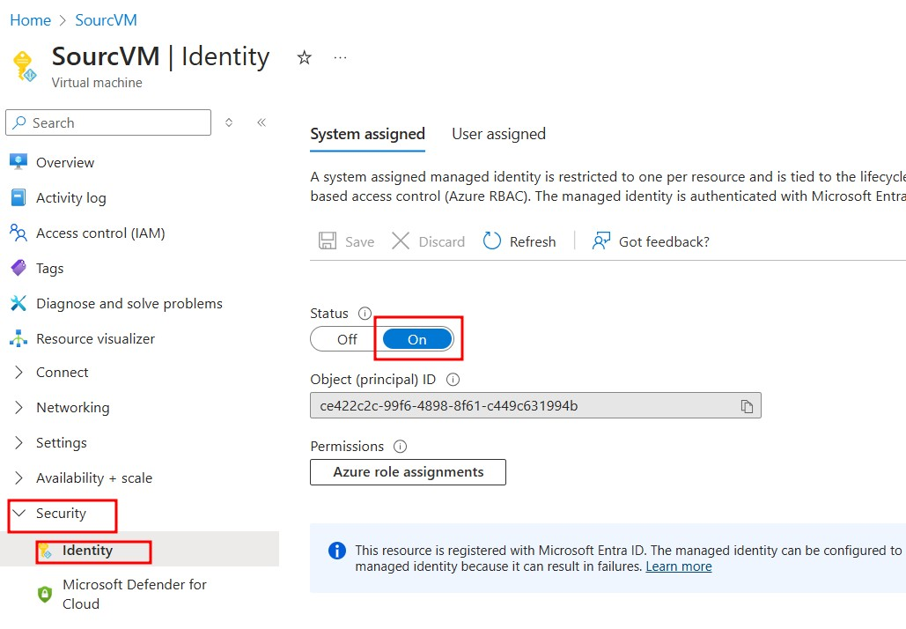

* Give your VM’s managed identity Monitoring Reader Role on Azure Monitor and Reader Role on your Subscription.
* In your Grafana VM, enable managed identity authentication for data sources by editing this file:

**/etc/grafana/grafana.ini**

Set:



* Restart the Grafana server by: **sudo systemctl stop grafana-server sudo systemctl start grafana-server**
* Open Grafana in your web browser (usually http://<your-server-ip>:3000) and log in with the default credentials (admin/admin).
* Navigate to Configuration > Data Sources and click on “Add data source.”
* Select “Azure Monitor” from the list.
* Choose to authenticate using Managed Identity

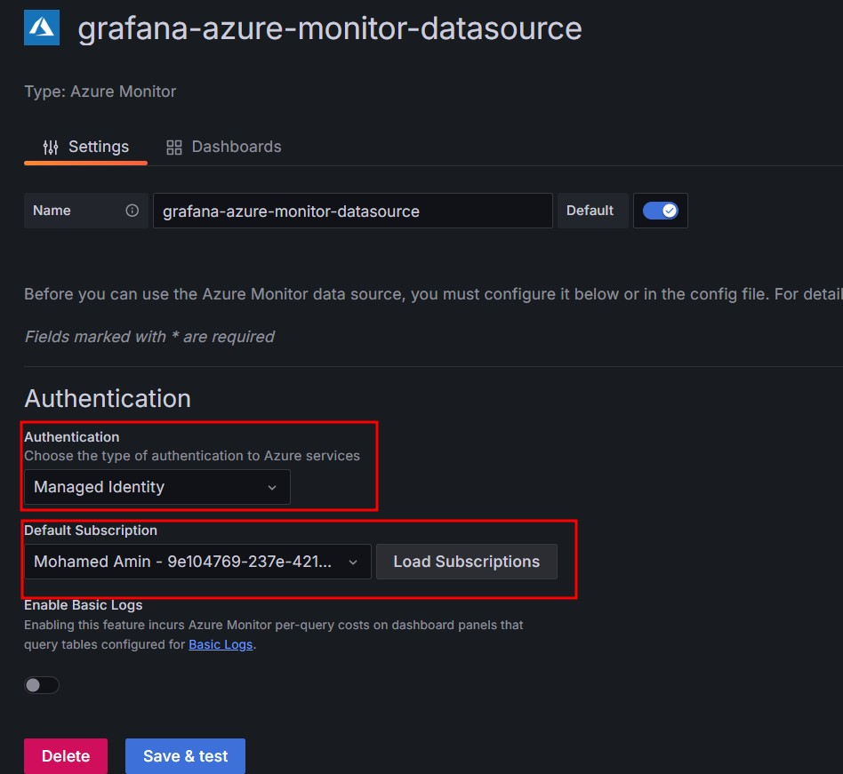

* Save and test the connection to ensure it is configured correctly.

# Task 4: Create a Dashboard in Grafana

* Click on the “+” icon on the left sidebar and select “Dashboard.”
* Click on “Add new panel.”
* From the data source dropdown, select “Azure Monitor.”
* Choose the relevant metrics that you would like to visualize, such as CPU usage, memory usage, network I/O, etc.
* Customize the panel with thresholds, colors, and labels.
* Save the panel and the dashboard.

Deliverables:

* A functioning Grafana dashboard showing your Ubuntu server's performance metrics.
* Screenshots documenting the setup process and the final dashboard.
* A brief report describing the steps taken and any issues encountered during the installation

and configuration process.

Evaluation Criteria:

Successful installation of Grafana and Azure Monitor agent.

Correct configuration of data source in Grafana.

Effective visualization of the Ubuntu server performance metrics.

Clarity and completeness of the submitted documentation. Submission Instructions:

Compile your screenshots and report into an MD file Submit the link for the Lab into your Github account to the submission portal before the due date.